Voltage Dividers
Voltage Divider ek resistor base circuit hota hai, jo bade voltage ko chote voltage me change kr deta hai.
Sirf 2 resister ko series me jodkar ek output voltage bna sakte hai.

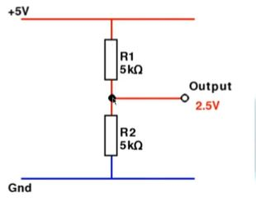
To calculate
https://ohmslawcalculator.com/voltage-divider-calculator

Pull-up Resistors
